Week 6 LLO – Probability

LO1 Define the probability of an outcome as the proportion of times the outcome would occur if we observed the random process that gives rise to it an infinite number of times

LO2 Explain why the long run relative frequency of repeated individual events settles down to the true probability as the number of trials increases i.e. why the law of large numbers holds

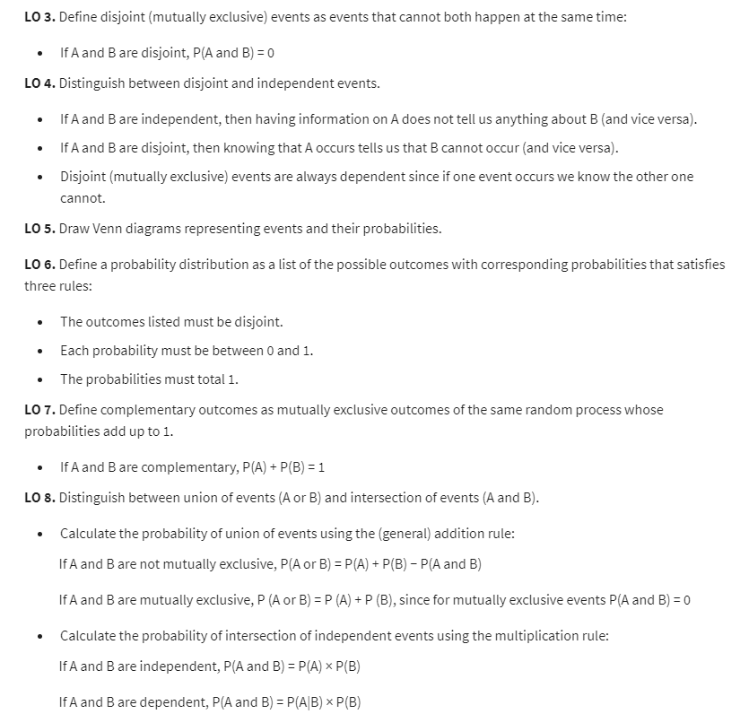

* Independence: two processes are independent if knowing the outcome of one provides no useful information about the outcome of the other
* Disjoint vs Independent
  + Disjoint: mutually exclusive, cannot happen at the same time
    - About events happening at the same time
    - P(A and B) = 0
  + Independence
    - About events not affecting each other
    - P(A|B) = 0
  + They are not the same thing!

LO9 Distinguish between marginal and conditional probabilities

LO10 Construct tree diagrams to calculate conditional probabilities and probabilities of intersection of non-independent events using Bayes Theorem

* Bayes Theorem

P(A|B) = P(A and B) / P(B)